DIAGRAMS/DRAWING FOR PROVISIONAL APPLICATION ID 73565085
A. General Architecture and Overview

FIG. 1 — Illustrates the Overall KHEPRA System Architecture and data flow, showing the dependency sequence from the Symbol Layer to the Zero Trust Engine.
B. Adinkra Algebraic Encoding (AAE) and QKE Protocol

FIG. 2 — Details the Adinkra Algebraic Encoding (AAE), mapping the bipartite graph structures of key symbols (Eban, Fawohodie, Nkyinkyim) to their algebraic representations and the $\mathbf{D_8}$ Dihedral Group operations.

FIG. 3 — Provides the flow chart for the Symbol-Derived Key Generation Pipeline, showing the process from Adinkra Symbol selection to the derivation of the entropy seed, candidate primes, and the final $\mathbf{KHEPRA}$ Key Material.

FIG. 4 — Illustrates the Post-Quantum Key Exchange Flow (ML-KEM-ready), showing the four-step sequence between Agent A and Agent B, and the final derivation of the shared keys ${k_{\text{enc}}, k_{\text{auth}}, k_{\text{audit}}}$ bound to symbolic salts.

B. Adinkra Algebraic Encoding (AAE) and QKE Protocol
- FIG. 2 — Details the Adinkra Algebraic Encoding (AAE), mapping the bipartite graph structures of key symbols (Eban, Fawohodie, Nkyinkyim) to their algebraic representations and the $\mathbf{D_8}$ Dihedral Group operations.
- FIG. 3 — Provides the flow chart for the Symbol-Derived Key Generation Pipeline, showing the process from Adinkra Symbol selection to the derivation of the entropy seed, candidate primes, and the final $\mathbf{KHEPRA}$ Key Material.
- FIG. 4 — Illustrates the Post-Quantum Key Exchange Flow (ML-KEM-ready), showing the four-step sequence between Agent A and Agent B, and the final derivation of the shared keys ${k_{\text{enc}}, k_{\text{auth}}, k_{\text{audit}}}$ bound to symbolic salts.

C. Agent Consensus Protocol (ACP) and Validation

FIG. 5 — Depicts the structure of the Agent Consensus Protocol (ACP) DAG, showing transaction vertices (Tx) linked by causal arrows, and illustrating how conflicts are resolved based on the Glyph Precedence Rules ($\text{Eban} > \text{Fawohodie} > \text{Nkyinkyim}$).
FIG. 6 — Is the Lorentz-Invariant Timestamping Diagram, showing the spacetime cone used by the Physics-Inspired Validation Layer to enforce causality by checking that actions remain within the causally allowed region ($\Delta s^2 \ge 0$).

D. Zero Trust Integration and Use Cases

FIG. 7 — Illustrates the continuous flow diagram of the Zero Trust Engine, detailing the $\mathbf{Continuous}$ $\mathbf{Authentication}$ $\mathbf{Loop}$ from Initial Authentication to Token Refresh, Monitored State, and eventual Session Termination or Re-Authentication.

FIG. 8 — Shows a DoD Enclave Authentication Flow (Eban Handshake), detailing the use case where a Field Agent presents an $\mathbf{Eban}$ $\mathbf{Symbol-Bound}$ $\mathbf{Credential}$ to an Access Gateway, triggering a continuous monitoring loop and a policy decision based on the Trust Score.

FIG. 9 — Illustrates the SATCOM Adaptive Rekeying and Station Handoff use case, detailing the dual-key window ($K_0+K_1$ valid) and the use of the $\mathbf{Nkyinkyim}$ symbol to trigger a rekey event based on factors like data volume or $\text{BER}$ (Bit Error Rate).

FIG. 10 — Depicts the mapping of various Regulators/Compliance Requirements (CMMC, HIPAA, GDPR, etc.) to the core $\mathbf{Symbolic}$ $\mathbf{Policy}$ $\mathbf{Mapping}$ $\mathbf{Engine}$, demonstrating how compliance rules are enforced via symbol semantics.

E. Prior Art Comparison

FIG. 11A — Prior Art Confidential Compute Attestation. This figure illustrates the limitations of existing solutions (Section 2.2), such as TPM, SEV, TDX, and Tinfoil-like services. The process only confirms that the $\mathbf{Hardware}$ $\mathbf{Root}$ $\mathbf{of}$ $\mathbf{Trust}$ and the $\mathbf{Secure}$ $\mathbf{Execution}$ $\mathbf{Enclave}$ are secure.

FIG. 11B — KHEPRA Protocol Agentic Security Attestation Framework (ASAF). This figure illustrates the integrated solution provided by KHEPRA, defining the ASAF category. The process combines Symbol-Bound Identity (AAE) and PQ Signing with the core KHEPRA DAG Provenance Engine.

FIG. 11C — Combined Comparison: Prior Art vs. KHEPRA. This table explicitly contrasts the deficiencies of the Prior Art against the advantages of KHEPRA.

4. BRIEF DESCRIPTION OF THE DRAWINGS
A. General Architecture and Overview.
FIG. 1 Overall KHEPRA System Architecture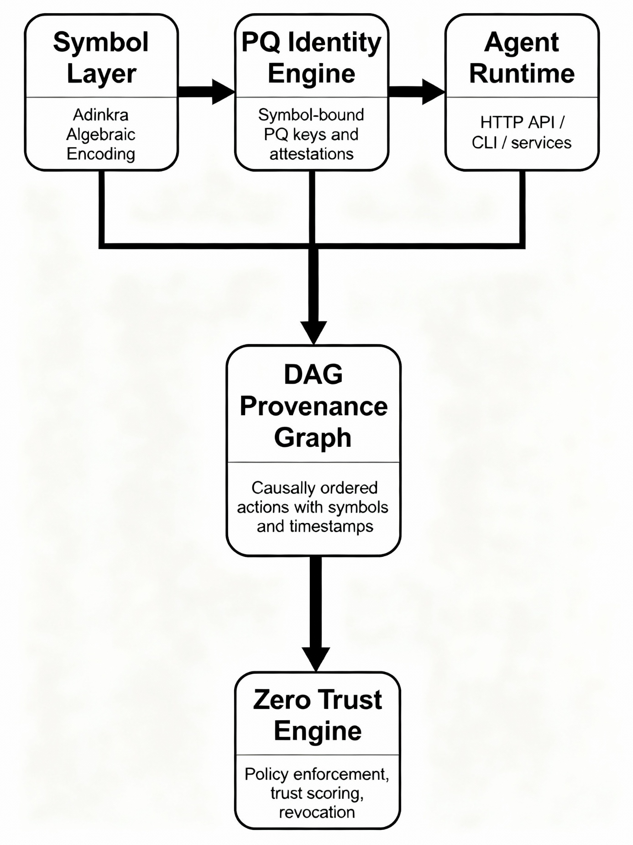

B. Adinkra Algebraic Encoding (AAE) and QKE Protocol

FIG. 2 Mapping Adinkra Symbols to $\mathbf{D_8}$ Dihedral Symmetry

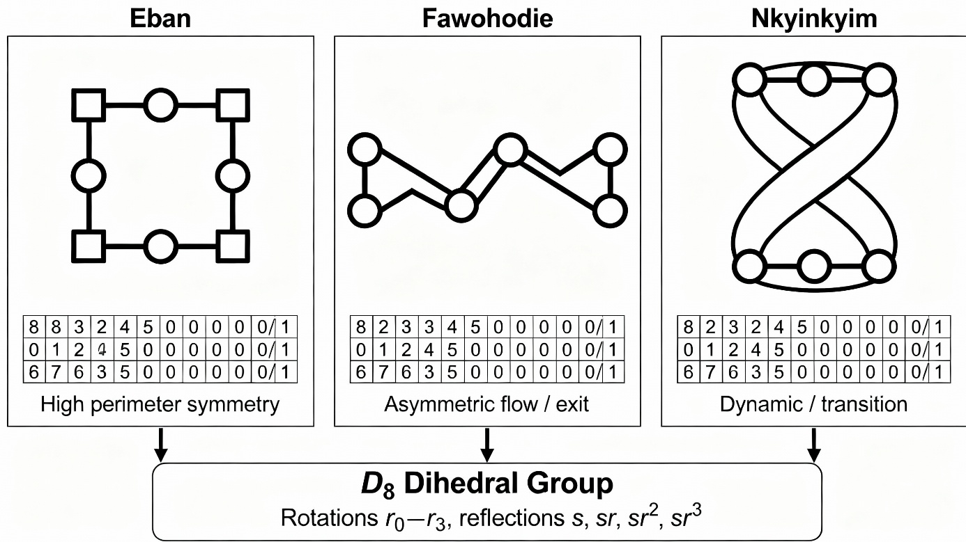

FIG. 3 Symbol-Derived Key Generation Pipeline

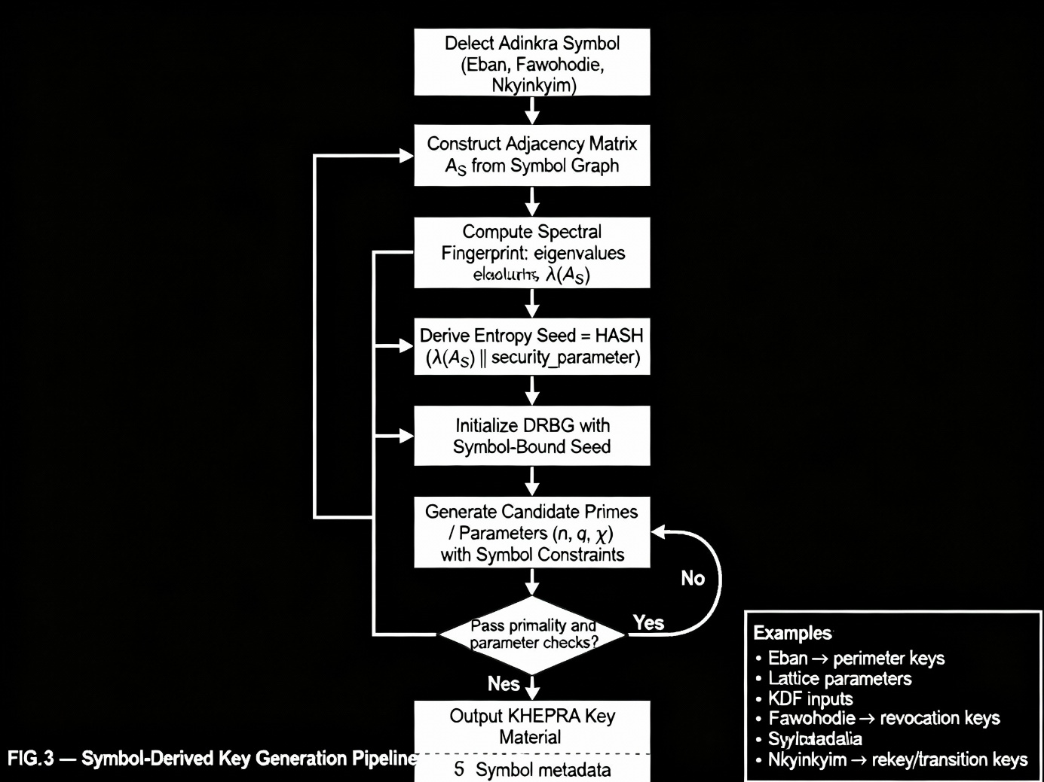

FIG. 4 PQ Key Exchange Flow (ML-KEM-ready)

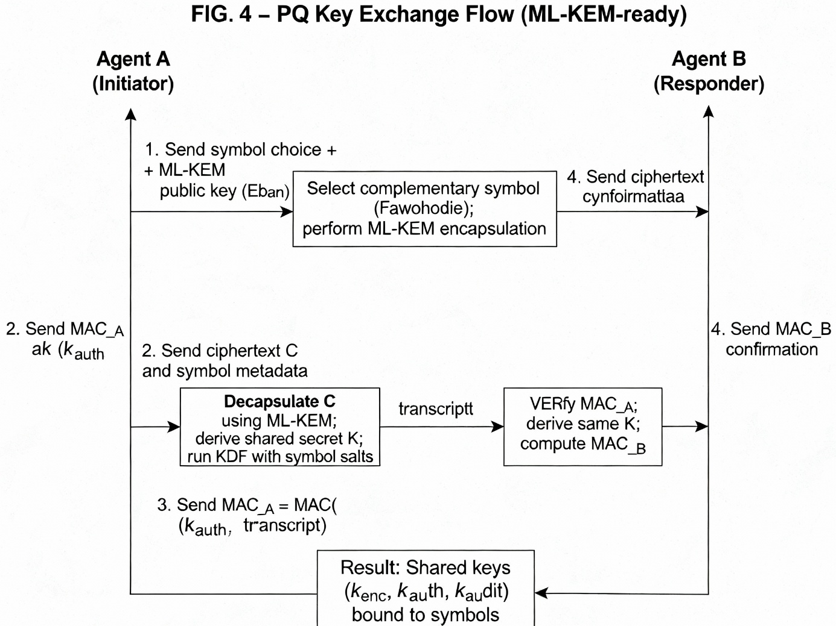

C. Agent Consensus Protocol (ACP) and Validation
FIG. 5 Agent Consensus DAG Structure with Glyph-Triggered Execution

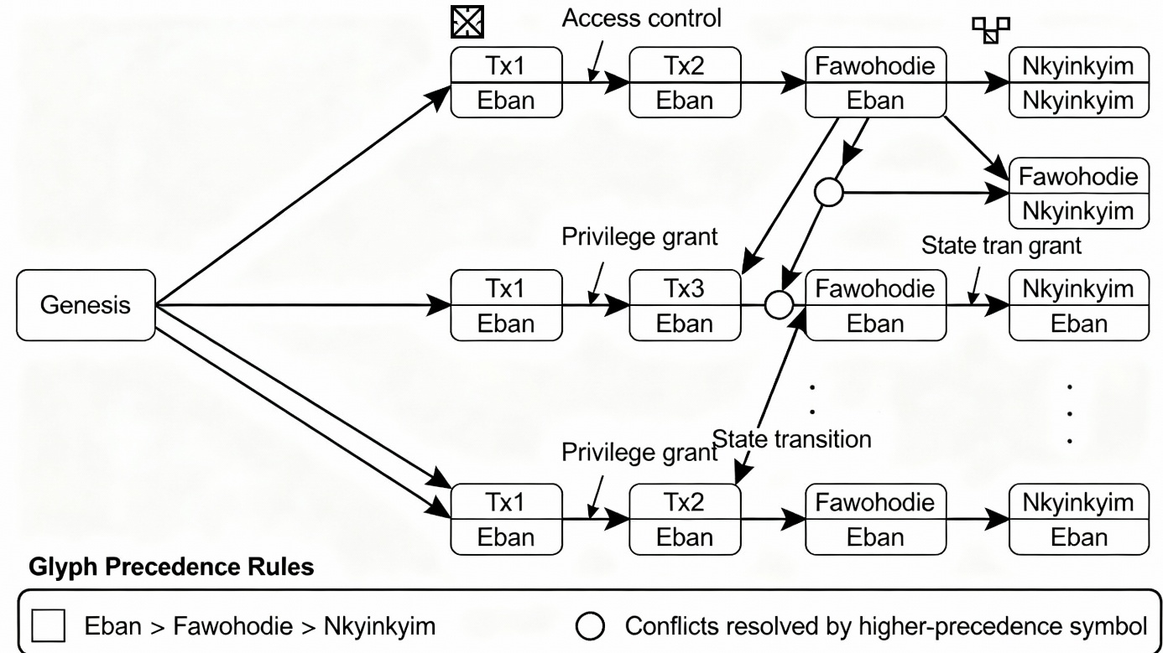

FIG. 6 Lorentz-Invariant Timestamping Diagram

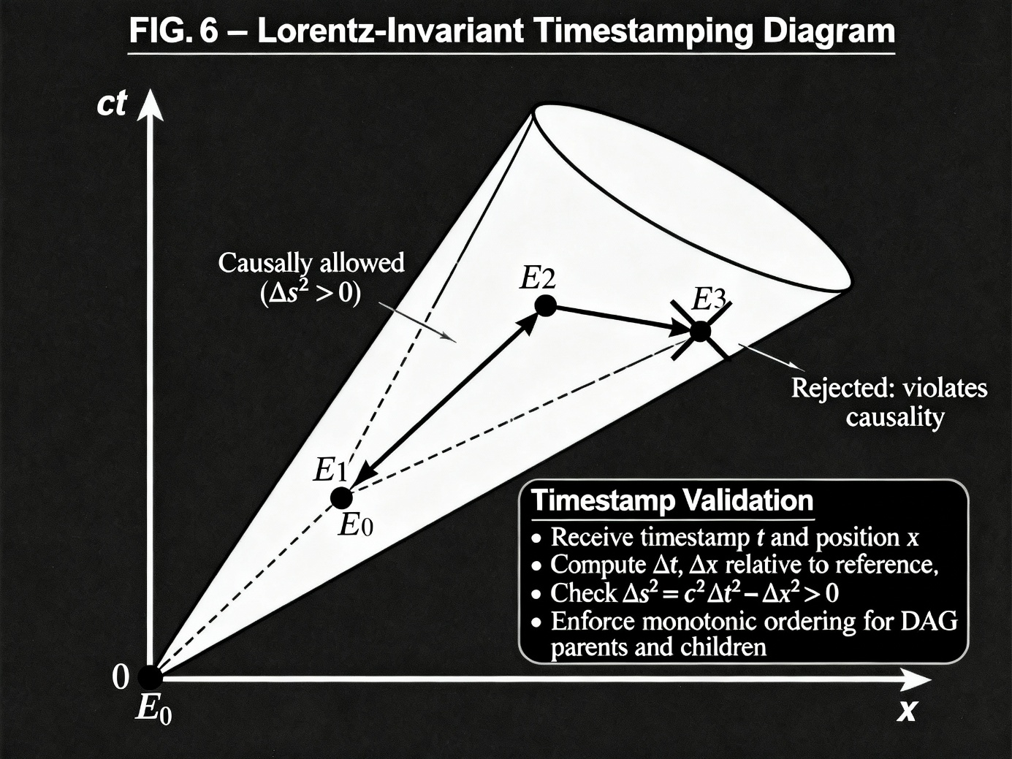

D. Zero Trust Integration and Use Cases
FIG. 7 Zero-Trust Enforcement Lifecycle for Autonomous Agents

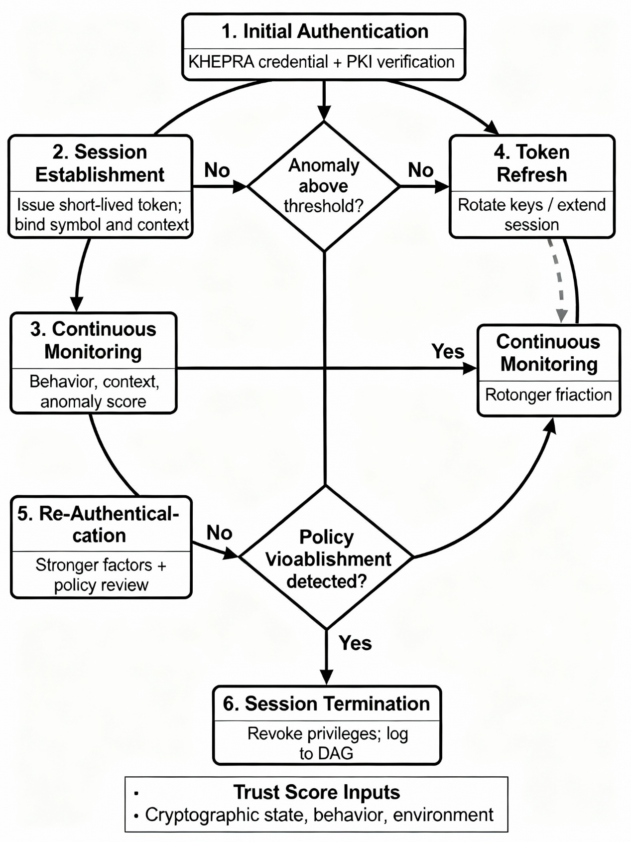

FIG. 8 DoD Enclave Authentication Flow (Eban Handshake)

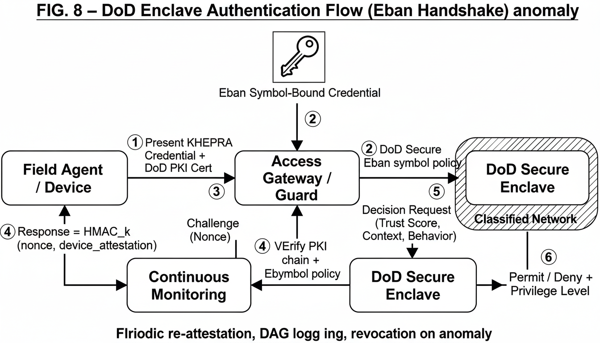

FIG. 9 SATCOM Adaptive Rekeying and Station Handoff

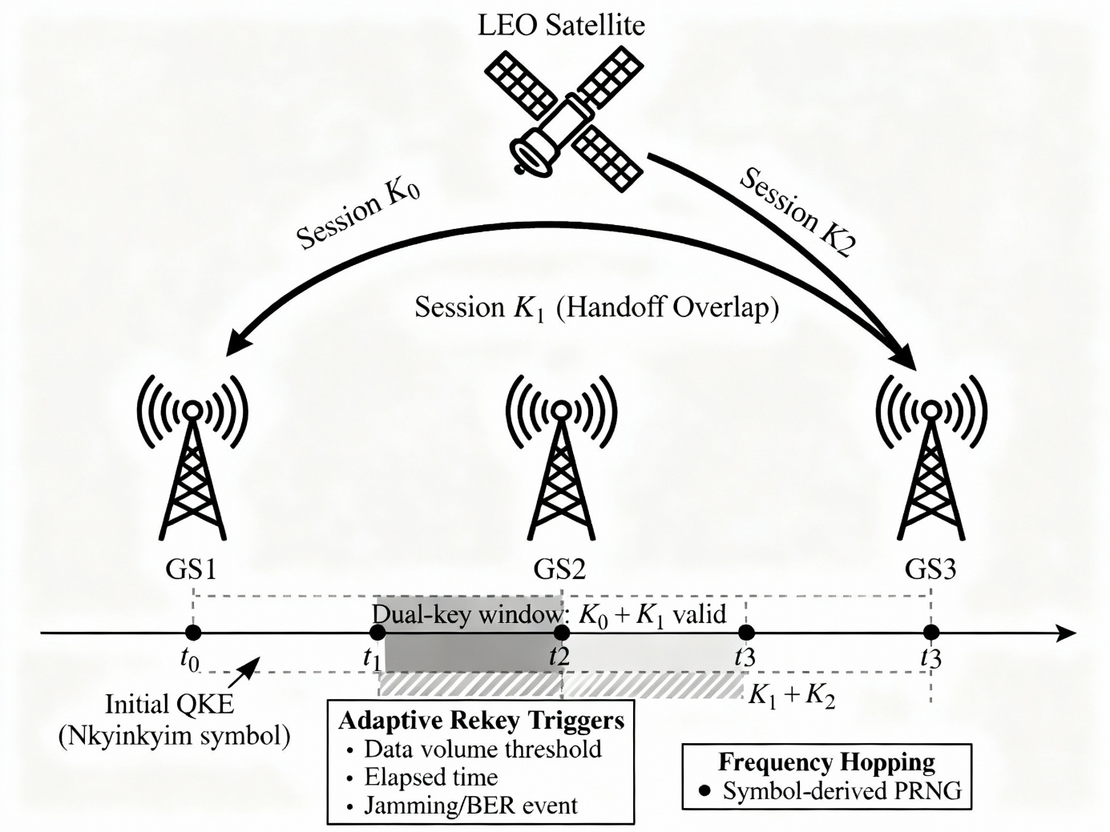

FIG. 10 Regulators / Compliance Mapping Using Symbol Semantics

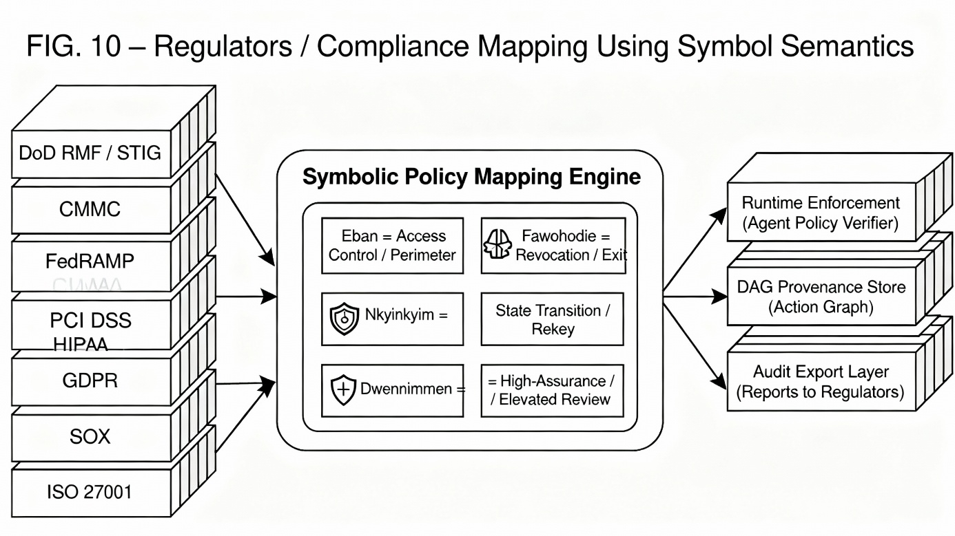
E. Prior Art Comparison
FIG. 11A Prior Art Confidential Compute Attestation

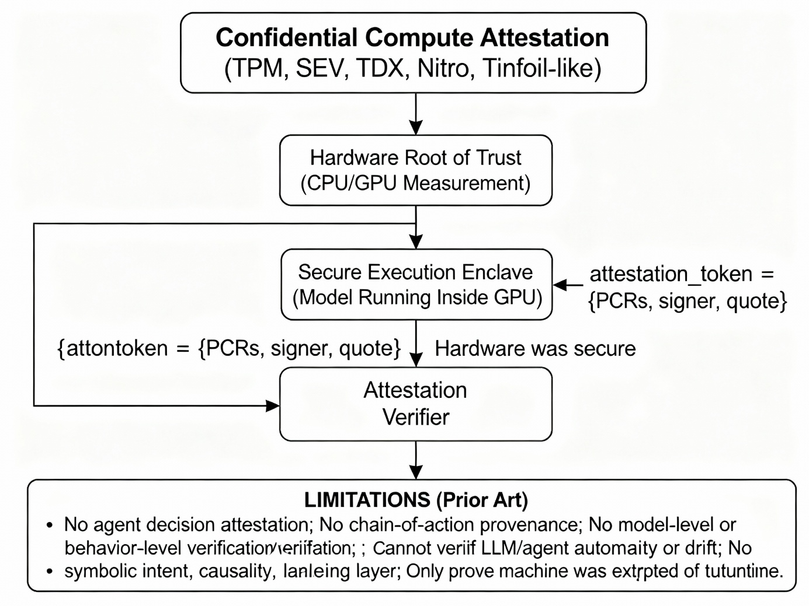

FIG. 11B KHEPRA Protocol Agentic Security Attestation Framework (ASAF)

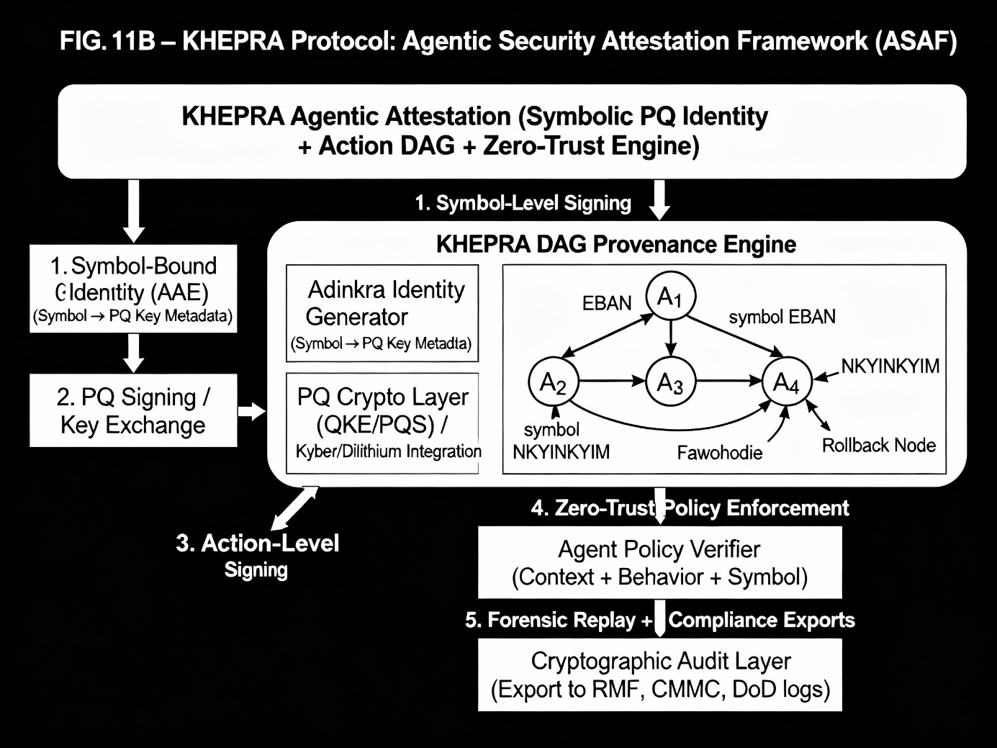

FIG. 11C Combined Comparison: Prior Art vs. KHEPRA
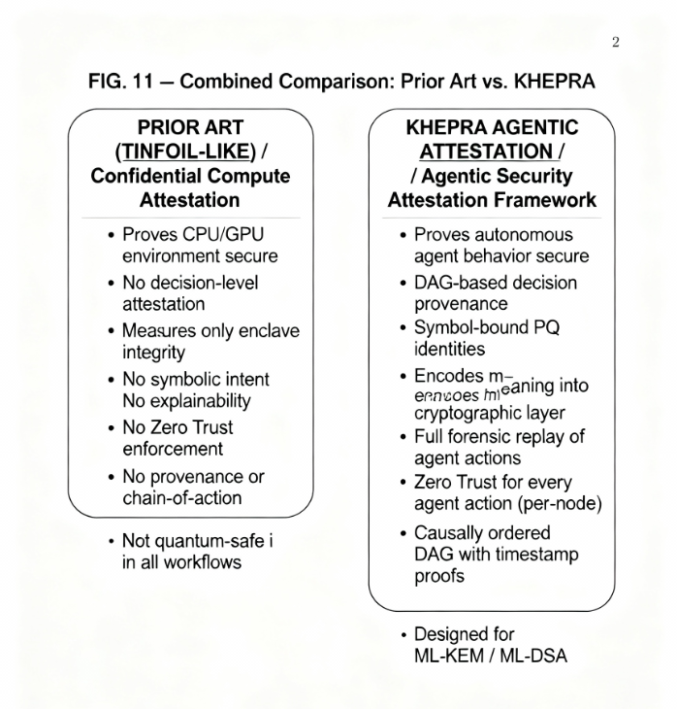

Signature:
Date: 12/17/2025
Typed Name: Souhimbou D. Kone
Registration Number: 73565085

